[Title] Template for the Journal of Creativity and Convergence:
[Subtitle] This is Short Title of the paper

Name First author's affiliation, an Institution with a very long name⁾
Second Author's Name Second author's affiliation, possibly the same institution
Third Author's Name Third author's affiliation, possibly the same institution

ABSTRACT
This submission template allows authors to submit their papers for review to an Awards, Conference or Journal without any output design specifications incorporated at this point in the process. The manuscript template is a single column document that allows authors to type their content into the pre-existing set of paragraph formatting styles applied to the sample placeholder text here.
An abstract must contain no more than 400 words. It should indicate the Background, Methods, Result, and Conclusion. If your review process will be double-blind: The submitted document should not include author information. Submissions containing author identifying information may be subject to rejection without review. Upon acceptance, the author and affiliation information must be added to your paper.

KEYWORDS
Insert comma delimited author-supplied keyword list, Keyword number 2, Keyword number 3, Keyword number 4

1. Introduction (12 point)

The manuscript submission template aims to provide consistent styles for use across publications of Design Research Institute for Creativity and Convergence. This submission template allows authors to submit their papers for review to an Awards, Conference or Journal.

1.1. More about the Submission Template (12 point)
Following the guidelines throughout this template will also improve the accessibility of your manuscript and increase the audience for your work. Ensure that heading styles are applied as instructed, tables are created using Word’s table feature (rather than an image), figures have a text equivalent, and list styles are applied as instructed.
This submission version of your paper should not have headers or footers, these will be added when your manuscript is processed after acceptance. It should remain in a one-column format—please do not alter any of the styles or margins.
If a paper is accepted for publication, authors will be instructed on the next steps. Authors must then follow the submission instructions found on their respective publication’s web page. Once your submission is received, your paper will be processed to produce the formatted Word, PDF, and HTML5 output formats, which will be provided to you for review, revision/resubmission (if applicable), and approval.

2. Inserting Content Elements

The next subsections provide instructions on how to insert figures, tables, and equations in your document.

2.1. Tables
Tables are “float elements” which should be inserted after their first text reference and have specific styles for identification. Do not use images to present tables, or they will be inaccessible to readers using assistive technologies.
Authors can insert tables by using the MS Word option (INSERT ->Table) and providing the required row and column size. Every table must have a caption (title) above it, which must have the “TableCaption” style applied. Please note that tables should not be supplied as image files, but if they are images they must have the “Image” style applied. As an example, Table 1 shows all the styles available in this template, to be applied to the respective element of your text.

Table 1 Styles Available in the Word Template (9 point, First word capitalized)

Style Tag | Definition | Style Tag | Definition
Title_Document | Main title of Article | List Paragraph | List Items
Subtitle | Subtitle of Article | Statements | Math Statements
Authors | Author name | Extract | Block Quotations
Affiliation | Author Affiliation Information | Algorithm Caption | Caption for Algorithm
Short Title | Short Title of Article

2.2. Figures
Figures are “float elements” which should be inserted after their first text reference, and have specific styles for identification. Insert a figure and apply the “Image” paragraph style to it. For the figure caption, apply the style “Figure Caption.”
2.2.1. Half Width Figures
Figure 1 is an example of a figure and caption spanning the half-page width (one column in a two column format) with the styles applied. If your figure contains third-party material, you must clearly identify it as such, as shown in the example below.
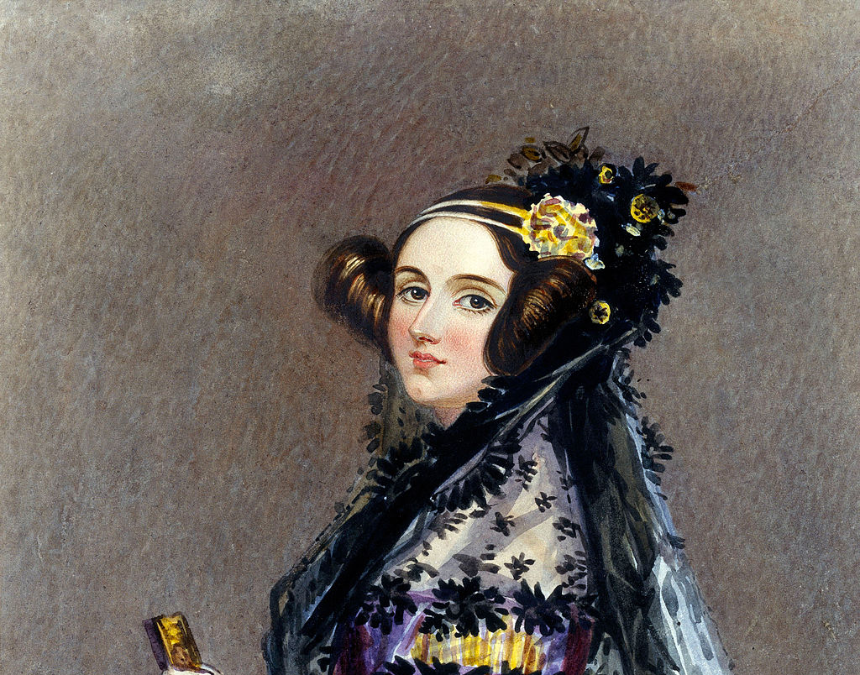
Figure 1 Watercolour portrait of Ada King, Countess of Lovelace, circa 1840, possibly by Alfred Edward Chalon [Public domain], via Wikimedia Commons. (https://en.wikipedia.org/wiki/Ada_Lovelace#/media/File:Ada_Lovelace_portrait.jpg)

2.2.2. Full Width Figures
Figure 2 is an example of a figure and caption spanning the full-page width with the styles applied. If your figure contains third-party material, you must clearly identify it as such, as shown in the examples.
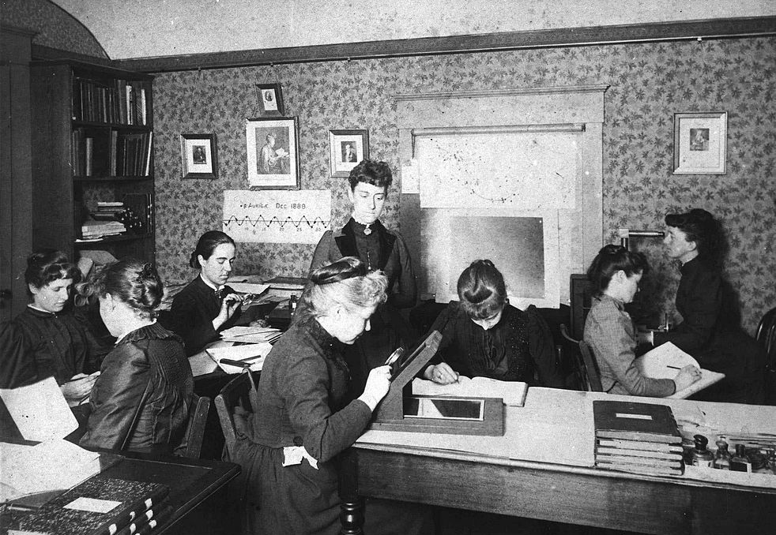
Figure 2 Astronomer Edward Charles Pickering's Harvard computers. [Public domain], via Wikimedia Commons. (https://en.wikipedia.org/wiki/Women_in_computing#/media/File:Astronomer_Edward_Charles_Pickering's_Harvard_computers.jpg)

2.2.3. Multi-part figure
Authors can also insert a multi-part figure above a single caption. Every inserted figure must have the “Image” style applied. Below are instructions regarding how to insert a multi-part figure in your paper.
- If the author wants to insert two multi-part images, they must draw a one row and one column table and insert the images one-by-one in the cells.
- If the author wants to insert three multi-part images, they must draw a one-row and three-column table and insert the images one by one in all three cells.
- If the author wants to insert four multi-part images, they must draw a two-row and two-column table and insert the images one-by-one in all four cells. (see the following example):
Figure 3 The layout of multipart images should be as per the above example within the table. All images must have the “Image” style applied.

2.2.4. Figure Descriptions
Every figure should have a figure description unless it is purely decorative. These descriptions convey what’s in the image to someone who cannot see it. They are also used by search engine crawlers for indexing images, and when images cannot be loaded.
A figure description must be unformatted plain text less than 100 characters long. Figure descriptions should not repeat the figure caption – their purpose is to capture important information that is not already provided in the caption or the main text of the paper. For figures that convey important and complex new information, a short plain text description may not be adequate.

2.3. Quotations
The use of footnotes is discouraged. They must be incorporated into the text. In the paper, reference must indicate within the text using the author/ date referencing style recommended by the American Psychological Association(APA), e.g. where author’'s name appears within the text, “"As Kim and Lee (2010: p 7) suggest”", or all in parentheses where author’'s names are not cited specifically in text, e.g. “"As some authors suggest (Kim, 1999; Lee, 2010)”".

2.4. Equations
There are two types of math equations: the numbered display math equation and the un-numbered display math equation. Below are examples of both.

2.4.1. DisplayFormula
The DisplayFormula style is applied in the numbered math equation. A numbered display equation always has an equation number (label) on the right.
$\frac{x=-b±\sqrt{b^{2}-4ac}}{2a}$ (1)
2.4.2. Display Formula.Unnum
The DisplayFormulaUnnum style is applied only in unnumbered equations. An unnumbered display equation never contains an equation number Bertot and Grimes (2012) on the right—this element distinguishes it from the numbered equation.
$$\frac{x=-b±\sqrt{b^{2}-4ac}}{2a}$$
3. Computer Code

Display Computer codes can be inserted using “ComputerCode” style.
CHAT Start
SAY Welcome to my world
WAIT 1.2
SAY Thanks for Visiting
ASK Do you want to play a game?
OPT Sure
OPT No Thanks
Similary, this is an example of intext code text.
Similary, this is an example of intext code text.

References

The list of references should only include works that are cited in the text and must follow the APA system. Some citation examples from the APA style are shown below:

[Books]
• Basic Form:
Struk, W., Jr., & Wite, E. B. (1979). The guide to everything and then more stuff. New York, NY: Macmillan.
• A Translation:
Laplace, P. S. (1951). A philosophical essay on probabilities (F. W. Truscott & F. L. Emory, Trans.). New York, NY: Dover. (Original work published 1814)
Note: When you cite a republished work, like the one above, in your text, it should appear with both dates: Laplace (1814/1951).
• Article or Chapter in an Edited Book:
Bergquist, J. M. (1992). German Americans. In J. D. Buenker & L. A. Ratner (Eds.), Multiculturalism in the United States: A comparative guide to acculturation and ethnicity (pp. 53–76). New York, NY: Greenwood.
• Edition Other Than the First:
Greory, G., & Pary, T. (2006). Designing brain-compatible learning (3rd ed.). Thousand Oaks, CA: Corwin.
• Multivolume Work:
Wiener, P. (Ed.). (1973). Dictionary of the history of ideas (Vols. 1–4). New York, NY: Scribner’s.

[Article in Periodicals]
• Basic Form:
Gable, R. A. (2004). Hard times and an uncertain future: Issues that confront the field of emotional behavioral disorders. Education and Treatment of Children, 27(4), 341–352.
• Journal Article with DOI:
Paivio, A. (1975). Perceptual comparisons through the mind's eye. Memory & Cognition, 3, 635-647. doi:10.1037/0278-6133.24.2.225
• Review:
Det-Read, C., & Zukow-Goldring, P. (2001). Is modeling knowing? [Review of the book Models of cognitive development, by K. Richardson]. American Journal of Psychology, 114, 126–135.

[Other Print Sources]
• Reference list entry:
Vissing, K., Brink, M., Lonbro, S., Sorensen, H., Overgaard, K., Danborg, K., ... Aagaard, P. (2008). Muscle adaptations to plyometric vs. resistance training in untrained young men. Journal of Strength and Conditioning Research, 22(6), 179–181.
• Dissertation, Unpublished:
Ritzmann, R. E. (1974). The snapping mechanism of Alpheid shrimp (Unpublished doctoral dissertation). University of Virginia, Charlottesville, VA.
Oviedo, S. (1995). Adolescent pregnancy: Voices heard in the everyday lives of pregnant teenagers (Unpublished master’s thesis). University of North Texas, Denton, TX.
• Government Document:
National Institute of Mental Health. (1990). Clinical training in serious mental illness (DHHS Publication No. ADM 90-1679). Washington, DC: U.S. Government Printing Office.
• Conference Proceedings:
Schnase, J. L., & Cunnius, E. L. (Eds.). (1995). Proceedings from CSCL ‘95: The First International Conference on Computer Support for Collaborative Learning. Mahwah, NJ: Erlbaum.

[Electronic Sources]
• Article From an Online Periodical:
Bernstein, M. (2015). Ten tips on writing the living web. A List Apart: For People Who Make Websites, 149. Retrieved from http://www.alisapart.com/articles/writeliving
• Article From an Online Periodical with DOI Assigned:
Browlie, D. (2003). Toward effective poster presentations. European Journal of Marketing, 41, 1224-1245. http://doi:10.1108/03090560710821861
• Article From an Online Periodical with no DOI Assigned:
Hamfi, A. G. (1981). The funny nature of dogs. E-journal of Applied Psychology, 2(2), 38–48. Retrieved from http://ojs.lib.swin.edu.au/index.php/fdo
• Electronic Books:
Browlie, D. (n.d.). Taytay’s tales: Traditional Pueblo Indian tales. Retrieved from http://digital.library.upenn.edu/women/dehuff/taytay/taytay.html
• Online Newspaper Articles:
Becker, E. (2001, August 27). Prairie farmers reap conservation's rewards. The New York Times. Retrieved from http://www.nytimes.com

) xxxx@gmail.com

